**DAILY ONLINE ACTIVITIES SUMMARY**

|  |  |  |  |  |  |  |  |  |
| --- | --- | --- | --- | --- | --- | --- | --- | --- |
| **Date:** | **31-05-2020** | | | | | **Name:** | **Veekshith Shetty** | |
| **Sem & Sec** | **8th sem B sec** | | | | | **USN:** | **4AL16CS094** | |
| **Online Test Summary** | | | | | | | | |
| **Subject** | | **SMS** | | | | | | |
| **Max. Marks** | | **60** | | **Score** | | | **60** | |
| **Certification Course Summary** | | | | | | | | |
| **Course** | **RPA** | | | | | | | |
| **Certificate Provider** | | | **GUVI** | | **Duration** | | | **3hrs** |
| **Coding Challenges** | | | | | | | | |
| |  | | --- | | **Problem Statement:** :c program to print right angled triangle number star pattern. | | | | | | | | | |
| **Status: completed** | | | | | | | | |
| **Uploaded the report in Github** | | | | | **yes** | | | |
| **If yes Repository name** | | | | | [**Veekshith-Shetty**](https://github.com/alvas-education-foundation/Veekshith-Shetty) | | | |
| **Uploaded the report in slack** | | | | | **yes** | | | |

Online Test Details: (Attach the snapshot and briefly write the report for the same)

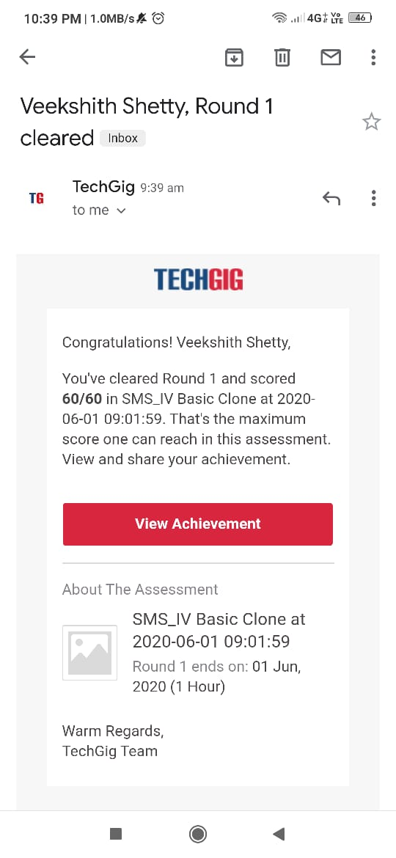

Certification Course Details: (Attach the snapshot and briefly write the report for the same)

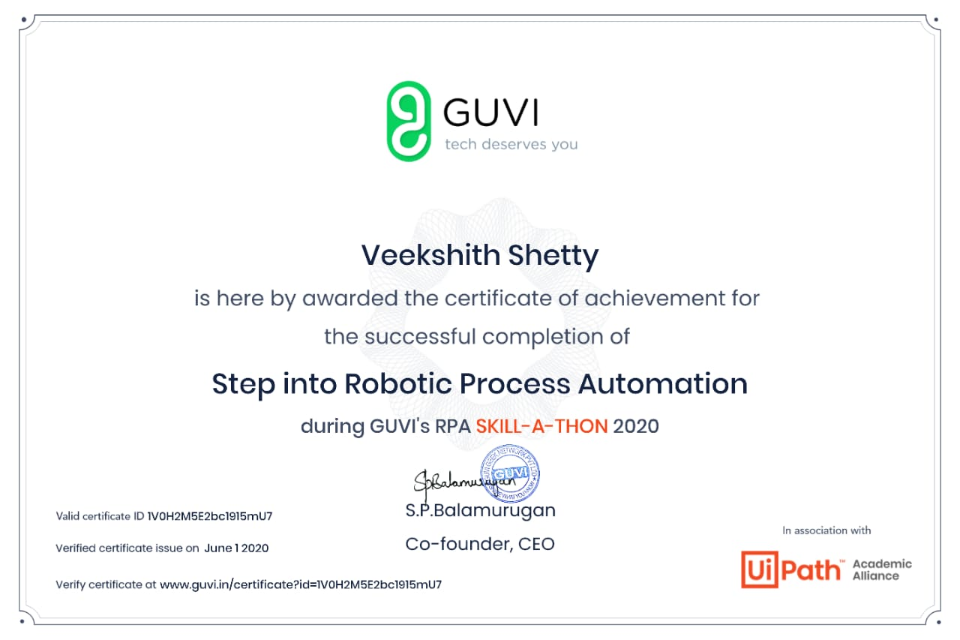

Coding Challenges Details: (Attach the snapshot and briefly write the report for the same)

Coding was given n it was uploaded for github and slack

PROGRAM1

int main()

{

int rows,I,j;

printf ("please enter the number of rows");

scanf("%d",&rows);

printf("printing the pattern");

{

for(j=1;j<=I;j++)

{

printf ("*");

}

printf ("\n");

}

return 0;

}